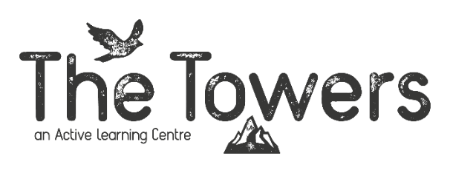

Centre Assistant
The Towers Active Learning Centre, Capel Curig, Eryri (Snowdonia)

40 hrs per week. Fixed term contract
Salary: National minimum wage depending on age
Start date: 25th January 2027
End date: 30th November 2027
Accommodation will be provided on site at costs relative to NMW level. Meals will be provided when groups are in residents.

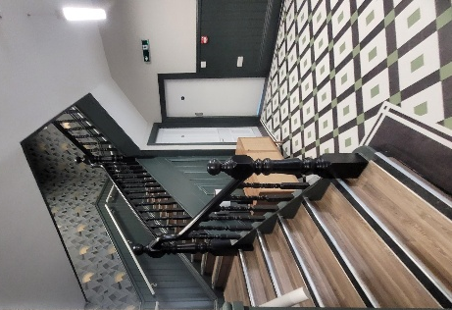
Closing Date for applications: 9th November 2026
To apply please email your CV and a covering letter telling us about yourself, please send these to Kayleigh.day@activelearningcentres.co.uk

About The Towers Active Learning Centre

From woods to coast to mountains, Active Learning Centres are dedicated to helping young people develop essential skills and character, and to promote wellbeing through outdoor learning.

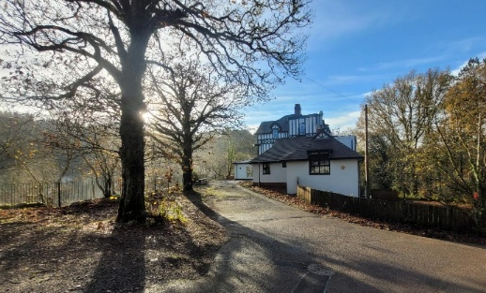
The Towers Active Learning Centre is set in the heart of Eryri National Park (Snowdonia), a few miles from Betws-Y- Coed and on the banks of the Afon Llugwy. Our centre has undergone full refurbishment to create a modern, fit for purpose and comfortable outdoor learning centre with excellent facilities for both our guests and staff.
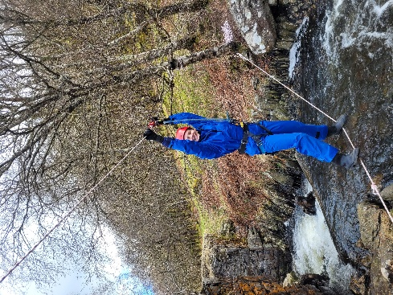
Using The Towers as our base, we are able to explore the mountains, valleys and rivers of north Wales to deliver adventurous residential courses which are designed to promote the development of Essential Skills, Character and Wellbeing. Working alongside our groups, we identify areas for development and deliver bespoke positive outcomes and experiential experiences.

Activities we run:
- Mine exploration
- gorge scrambling
- Via ferrata
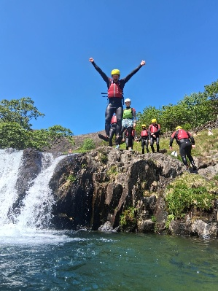
- Abseiling
- Mountain walk / scramble
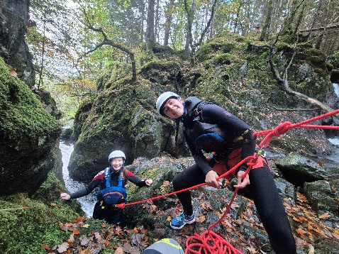
- Coasteering
- Beach explore
- Climbing
- Canoeing
- Bushcraft
- Weaseling / Bouldering
- Stand up paddleboarding
- And more…..

About the Role
This is an exciting opportunity to join The Towers team, we are looking to recruit 2 Centre Assistants. This role requires enthusiasm, passion, energy, and a willingness to learn. We are looking for individuals that want to join us in driving The Towers forward, make it an incredible and positive place to work and ensure our groups leave with great memories that will last them a lifetime. You will learn all areas of the centre’s operations and work with some great staff that will help you learn about centre life. You will have the opportunity to be mentored in the delivery of outdoor learning using adventure activities as the vehicle for learning, as well as having the opportunity to lead your own groups.

Responsibilities
- Assist in facilitating our core program in the areas of Essential Skills, Character and Wellbeing using our skills builder program to ensure positive outcomes
- Work with our instructors on a range of adventurous activities and seek opportunities to gain experience leading these activities
- Oversee the arrival and departures of groups and liaising with visiting staff members to ensure that their visit is successful
- Act as an ‘on call’ point of contact out of office hours supported by senior centre staff
- Contribute to the day to day operations of the centre
- Assist with ensuring the guest accommodation is ready for use prior to arrivals
- Assist in the kitchen and carry out basic kitchen assistant tasks
- Assist with general centre and venue maintenance tasks
- Take responsibility for your own learning by seeking opportunities to work with different instructors, further your own knowledge and learn about different groups and individual’s needs.

Working pattern
- The role will consist of:
  - Assisting with instructional sessions
  - Domestic work
  - Site maintenance work
  - Training/Technical training
  - Once signed off the aim is for you to be running sessions/whole or in part

About You

You will be able to demonstrate passion and enthusiasm to work with young people and learn new skills. Will support you in your learning of both hard and soft skills but it’s essential you have a “can do” attitude and be prepared to be involved in all areas of the centre.

Desirables:
- Previous experience of working with young people
- Outdoor qualifications
- Enthusiasm for the outdoors and outdoor learning
- Practical experience in the outdoors

Interview:
- Interview Date: 30th November and 1st December.
- This will be a two day interview including practical workshops/sessions, formal interview and a social aspect on the evening. All food and board provided.

Any questions please contact: Kayleigh.day@activelearningcentres.co.uk

