|  |
| --- |
| IOL Accredited Resource  Application |

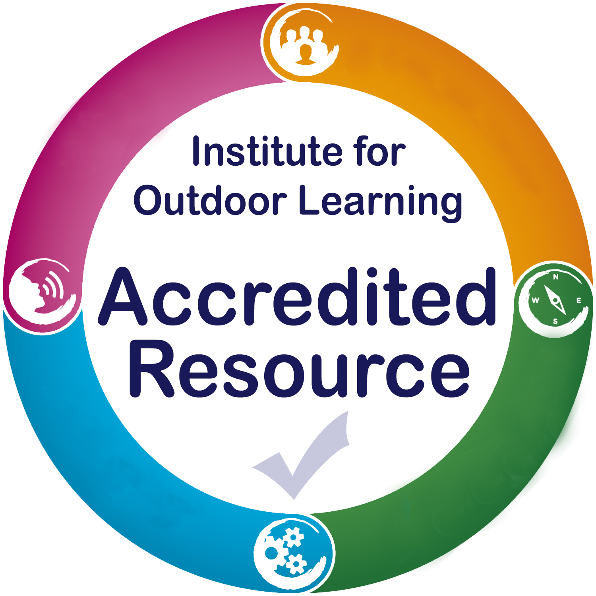A quality mark for resources that can support effective outdoor learning.

|  |  |
| --- | --- |
| Resource Title |  |

**Please refer to the IOL accredited resource application   
guidance notes as you complete this form.**

|  |  |
| --- | --- |
| Provider Name |  |
| Contact Name |  |
| Contact Address |  |
| Phone |  |
| Email |  |

|  |
| --- |
| 1 Resource Purpose, Description and Use |
| Does the resource have a clear purpose, target market and is it appropriately designed for users? |

|  |  |  |  |
| --- | --- | --- | --- |
| 1.1 | **Statement of Ownership** | | |
| 1.1.1 | Who was responsible for the design and development of the resource? |  | |
| 1.1.2 | Who holds the intellectual property rights for this resource? | Name |  |
| *We are only willing to accredit resources that you hold the intellectual property rights to. Do not ask IOL to accredit a resource that that is covered by someone else’s copyright, patent or trademark, etc.* | |

|  |  |  |
| --- | --- | --- |
| 1.2 | **Clear Purpose** | |
| 1.2.1 | Name of resource |  |
| 1.2.2 | Aim of the resource  *(what does it do/offer users?)* |  |
| 1.2.3 | Key benefits of the resource for supporting outdoor learning |  |

|  |  |  |  |
| --- | --- | --- | --- |
| 1.2.4 | Is the resource primarily designed to meet the syllabus of a qualification or award? | **YES or NO** |  |
| **Qualification or award:**  **Criteria supported:** | |
| 1.2.5 | Which outdoor learning qualifications or awards can this resource support? |  | |

|  |  |  |  |  |  |
| --- | --- | --- | --- | --- | --- |
| 1.3 | **Resource Description** | | | | |
| 1.3.1 | Which of these **impact or benefit areas** will the resource help users attain? | Academic achievement | | |  |
| New skills and knowledge | | |  |
| Personal and social development | | |  |
| Care for the environment | | |  |
| Career and professional development | | |  |
| Wellbeing and mental health | | |  |
| 1.3.2 | Which (if any) of these **outdoor activity / subject areas** does the resource relate to? | | | | |
| Adventure Sports | |  | Nature Connection |  |
| Outdoor Skills and Challenges | |  | Outdoor Science |  |
| 1.3.3 | Resource format  IOL is not seeking to accredit published books. We are willing to consider accrediting guides and resources relevant to outdoor learning professionals. | | | | |
| Download | |  | Physical product(s) |  |
| Online website or app | |  | Other (describe) |  |
| Printed material (sheets / booklet) | |  |  |  |
| 1.3.4 | Resource type  Select ONE of the options | **Self-Led** – designed to guide, support or enhance either a formal or informal outdoor learning experience. *(e.g. resource cards, identification guides, etc.)* | | |  |
| **Professional Led** – designed to be used by professionals with individuals or groups when delivering an outdoor learning session or programme. *(e.g. award schemes)* | | |  |
| 1.3.5 | Primary or intended audience | | | | |
| Age Range: 1-5 5-9 9-11 11-15 15-18 18-21 21-35 35-65 65+  Academic Level: 1 2 3 4 5 6 7  Number of users: 1-300 users per year more than 300 users per year | | | | |
| 1.3.6 | How is the resource typically expected to be used in outdoor learning?  (max 150 words) |  | | | |

|  |  |  |  |  |  |
| --- | --- | --- | --- | --- | --- |
| 1.3 | **Usability** | | | | |
| 1.4.1 | Send a sample of the resource for assessment purposes | Sent by email |  | Sent by post |  |
| *With reference to the resource purpose (1.2) and description (1.3) we will assess the overall feel and usability of the resource and supporting materials.*  *We will consider your choice of physical size, material, textures, graphics, fonts, colours, readability, etc.* | | | |
| 1.4.2 | How does the design of the resource take equality and diversity into account?  (400 words max) |  | | | |
| 1.4.3 | How is the resource adaptable to the needs of individuals and groups? |  | | | |

|  |
| --- |
| 2 Relevance to Outdoor Learning |
| Does the resource support and encourage high quality outdoor learning? |

|  |  |  |  |
| --- | --- | --- | --- |
| 2.1 | **Outdoor learning target market and needs assessment** | | |
| 2.1.1 | What needs analysis was undertaken and what were the results? |  | |
| 2.1.2 | What research or consultations did you carry out to build on expertise within the Outdoor Learning field? |  | |
| 2.1.3 | How did you involve the Outdoor Learning field in your resource design / development? |  | |
| 2.1.4 | Two statements from the outdoor learning field that support the need or value in this resource. *E.g. case studies from learners, relevant peer endorsement, employer testimonials of need/relevance, etc.* | | |
| Supporting statement 1 | | | Supporting statement 2 | |
|  | | |  | |

|  |  |  |
| --- | --- | --- |
| 2.2 | **Supports high quality outdoor learning** | |
| Brief descriptions of how the resource can support high quality outdoor learning principles:  *(*[*https://www.outdoor-learning.org/Good-Praanctice/Good-Practice/High-Quality-Outdoor-Learning*](https://www.outdoor-learning.org/Good-Praanctice/Good-Practice/High-Quality-Outdoor-Learning)*)* | | |
| 2.2.1 | Enjoyment |  |
| 2.2.2 | Confidence and character |  |
| 2.2.3 | Health and wellbeing |  |
| 2.2.4 | Social and emotional awareness |  |
| 2.2.5 | Environmental awareness |  |
| 2.2.6 | Activity skills |  |
| 2.2.7 | Personal qualities |  |
| 2.2.8 | Skills for life |  |
| 2.2.9 | Increased motivation and appetite for learning |  |
| 2.2.10 | Broadened horizons |  |

|  |  |  |
| --- | --- | --- |
| 2.3 | **Supports IOL good practice in outdoor learning** | |
| 2.3.1 | IOL Statements of Good Practice this resource can support  *(Describe which parts of the statement the resource covers)* |  |
| 2.3.2 | Other relevant standards or guidance this resource can support |  |

|  |
| --- |
| 3 The Resource in Action (Quality Assurance) |
| Is the process for obtaining and using the resource clear and quality assured? |

|  |  |  |  |
| --- | --- | --- | --- |
| 3.1 | **Obtaining the Resource** | | |
| 3.1.1 | Who is able to obtain the resource | Open to all |  |
| Limited availability | *Describe below in 3.1.3 and 3.1.4* |
| 3.1.2 | Outline the process for how to obtain the resource |  | |
| 3.1.3 | What (if any) qualifications or awards are required by those **obtaining** the resource? |  | |
| 3.1.4 | What (if any) qualifications or awards are required by those **using** the resource? |  | |
| 3.1.5 | How will you ensure users have the required qualifications / awards for obtaining and/or using the resource? |  | |
| 3.1.6 | How will you monitor users have the required qualifications / awards for using the resource? |  | |
| 3.1.7 | What action will you take if you find users without the required qualifications / awards are using the resource? |  | |

|  |  |  |  |
| --- | --- | --- | --- |
| 3.2 | **Using the Resource** | | |
| 3.2.1 | Is an instruction guide, booklet or scheme of work with suggestions for use in outdoor learning included? | Yes |  |
| No | *We are unable to accredit resources that do not include an instruction guide, booklet or scheme of work with suggestions for use in outdoor learning* |
| 3.2.2 | What additional support is available to users? |  | |

|  |  |  |
| --- | --- | --- |
| 3.3 | **Monitoring the Resource** | |
| 3.3.1 | What checks are in place to ensure users are using the resource as intended? |  |
| 3.3.2 | How will you monitor how the resource helps users achieve the expected benefits and outcomes? |  |
| 3.3.3 | How will you ensure the resource remains current and relevant to outdoor learning? |  |

|  |  |  |
| --- | --- | --- |
| 3.4 | **Feedback** | |
| 3.4.1 | How will feedback from all users be gathered and incorporated into future revisions or updates? |  |
| 3.4.2 | How are users informed and updated of resource developments? |  |

|  |
| --- |
| 4 Business Structure and Values |
| Is the business properly constituted and operating ethically in line with IOL policies? |

|  |  |  |  |
| --- | --- | --- | --- |
| 4.1 | **Properly constituted business with a sound financial position** | | |
| 4.1.1 | Business Name |  | |
| 4.1.2 | Business Purpose |  | |
| 4.1.3 | Legal structure | Sole Trader |  |
| Business Partnership |  |
| Limited Company |  |
| Charitable Incorporated Organisation |  |
| Other |  |
| 4.1.4 | Registered Details (where appropriate) | Companies House  Charity Commission | |
| 4.1.5 | Appropriate funds | Confirmation that sufficient funds are available to enable timely delivery of the resource |  |

|  |  |  |  |  |
| --- | --- | --- | --- | --- |
| 4.2 | **Operates ethically with the appropriate policies and procedures in place** | | | |
| 4.2.1 | Confirm you hold the following operational policies and procedures  We do not need to see them, just to be assured that you hold them. | Health and Safety | |  |
| Equality and Diversity | |  |
| Data Protection | |  |
| Environmental Impact | |  |
| Complaints Policy | |  |
| Risk - Benefit Assessments | |  |
| 4.2.2 | Insurance | Please confirm you hold insurance cover relevant to the course named in this application | |  | |
| Name of Insurers |  | | |
| Policy Expiry Date |  | | |
| 4.2.3 | Other relevant organisational policies or procedures |  | | |

|  |  |  |  |  |
| --- | --- | --- | --- | --- |
| 4.3 | **Endorsements, accreditations or approvals** | | | |
| 4.3.1 | Two recent client testimonials (supporting the professional approach of your business) | | |
| Client 1 Testimonial | | | Client 2 Testimonial | |
|  | | |  | |
| 4.3.2 | Other accreditations, approvals or endorsements achieved |  | | |

|  |  |  |
| --- | --- | --- |
| 4.4 | **Motivation and drive** | |
| 4.4.1 | Why are you seeking IOL Resource Accreditation now? |  |
| 4.4.2 | What tangible benefits are you hoping IOL Resource Accreditation will bring? |  |
| 4.4.3 | Is there anything in addition to resource accreditation that IOL could help you with? |  |

|  |
| --- |
| 5 Support for Outdoor Learning |
| Do you as the resource provider show active support for IOL and the Outdoor Learning sector? |

|  |  |  |  |  |
| --- | --- | --- | --- | --- |
| 5.1 | Membership of the Institute for Outdoor Leaning | Organisational Membership Number | |  |
| Organisational Member Level | |  |
| Date joined |  | |
| 5.2 | Resource Manager - name of person who is responsible for overseeing the resource | Name |  | |
| IOL Membership Category |  | |
| 5.2.1 | Brief statement of why outdoor learning is of value to wider society. (400 words max) | ***Not required if resource manager is a Registered member of IOL, Accredited member of IOL, or Leading member of IOL.*** | | |

|  |
| --- |
| IOL Accredited Resource Application |

By applying to have you resource accredited by IOL you agree:

1. You hold the rights to the intellectual property for this resource
2. To send a sample of the resource to IOL for accreditation purposes
3. Your application will be assessed by the IOL Resource Accreditation board
4. To pay the appropriate fees for accreditation and renewal
5. You will report any planned changes to IOL and pay the appropriate fee
6. You will provide IOL with access to any relevant feedback you receive
7. You will provide IOL with the necessary information to create website links and promotional text for your accredited resource
8. The use of an IOL Accredited Resource Badge on any publications, products, websites or literature shall first be agreed with IOL.
9. IOL retains the right to withdraw accreditation at any time, including the reasons:

* Failure to comply with the accreditation criteria
* Failure to comply with the policies and processes submitted at accreditation
* Misuse of any branding, wording or logos of the Institute for Outdoor Learning

1. You will make opportunities and information available when requested for IOL to moderate the resource accreditation process

# Accredited Resource Application

Signed ______________________________ Position __________________________________

Name ______________________________ Date __________________________________

# Submitting your Application

Our preferred application method is via email with all files in .pdf format. Please send your completed form and attachments to [louise@outdoor-learning.org](mailto:louise@outdoor-learning.org)

It this is not possible, you can post you application to: Institute for Outdoor Learning, Warwick Mill Business Centre, Warwick Bridge, Carlisle, Cumbria. CA4 8RR

We will invoice you by return and we will begin assessing your application on receipt of payment.

# *IOL Accreditation Process*